Basic Design and Technology
BECE 2021 — Paper 1 (Objective)
1. The following are household furniture except
A. bookshelf.
B. cabinet.
C. chair.
D. television.
2. The shape of a developed open-ended cylinder is a
A. circle.
B. parallelogram.
C. rectangle.
D. rhombus.
3. A fuse is placed in a plug in order to
A. break when there is excessive current.
B. increase the flow of electricity.
C. oppose the flow of electric current.
D. stop the flow of electricity.
4. Evaluations are carried out on artefacts in order to
A. change the situation completely.
B. conduct a new research of the design.
C. increase the cost of artefact.
D. make modifications on the design.
Use Figure 1 to answer questions 5 and 6.
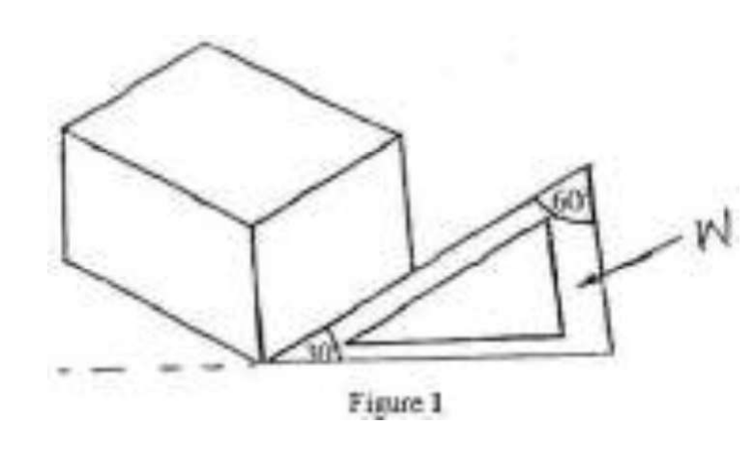
5. Figure 1 shows an object drawn in
A. isometric.
B. oblique.
C. orthographic.
D. perspective.
6. The instrument labelled W is a
A. protractor.
B. rule.
C. set square.
D. tee square.
7. The traditional forms of food preservation in Ghana are
A. bottling and freezing.
B. freezing and drying.
C. drying and salting.
D. salting and bottling.
8. A birthday cake is usually packed in a brown cardboard box
A. to attract customers.
B. for easy transportation.
C. to preserve flavour.
D. to give information.
9. A light meal eaten between the main meals of the day is referred to as
A. elevenses.
B. high tea.
C. brunch.
D. snack.
10. In table setting, the main reason for covering the table with a cloth is to
A. make the setting formal.
B. protect the table surface.
C. make the table attractive.
D. act as silencer.
11. An example of a wet medium is
A. chalk.
B. coloured pencil.
C. crayon.
D. poster colour.
12. What are the primary colours of pigment?
A. Red, yellow, green.
B. Red, blue, green.
C. Yellow, blue, green.
D. Red, yellow, blue.
13. Growth is symbolically represented with the colour
A. green.
B. red.
C. yellow.
D. white.
14. Placing value on an item is termed
A. costing.
B. labelling.
C. pricing.
D. selling.
15. Where the sky appears to meet the land is called the
A. horizon.
B. foreground.
C. background.
D. plane.
16. The aim of mending articles is to
A. add value to the item.
B. improve creative skills.
C. make the item useful.
D. make good use of leisure time.
17. Examples of second-class protein foods are
A. melon seeds, cheese and milk.
B. cowpeas, oysters and broad beans.
C. groundnuts, milk and melon seeds.
D. cowpeas, melon seeds and groundnuts.
18. One of the characteristics of plant fibres is that they
A. smoulder when burnt.
B. have low absorbency.
C. burn readily.
D. are wrinkle resistant.
19. An advantage of a freehand cutting is that
A. less fabric is used.
B. it is easy for beginners.
C. it saves time and energy.
D. a lot of pins are used.
20. Regenerated fabrics are obtained from
A. man-made fibre.
B. synthetic fibre.
C. natural fibre.
D. animal fibre.
21. Dishes that provide the body with concentrated form of energy are
A. vegetable soup and boiled rice.
B. boiled beans and gari.
C. vegetable salad and bread.
D. meatpie and queens cake.
22. Rickets causes weakness in bones and teeth of
A. adolescents.
B. elderly.
C. vegetarians.
D. children.
23. A disadvantage of grilling is that
A. food should always be basted.
B. it is slow method of cooking.
C. it needs constant attention.
D. most nutrients are lost.
24. An important factor to consider when purchasing fabric for a student is the
A. money available.
B. weather condition.
C. height of wearer.
D. size of wearer.
25. Faced openings are usually used on the
A. front part of boy's shirt.
B. side of girl's dresses.
C. back of students' uniforms.
D. side of skirts for the elderly.
26. Examples of dishes prepared using batter mixtures are
A. banana fritters and pancakes.
B. bread and rocks.
C. ring doughnuts and queens' cake.
D. pancake and biscuits.
27. The fat-soluble vitamins in a meal of kontonmire stew, boiled brown rice and baked egg custard are
A. Vitamin C and D.
B. Vitamin A and B.
C. Vitamin B and D.
D. Vitamin E and K.
28. The best stitch to use in transferring pattern markings onto fabric is
A. basting.
B. overcasting.
C. backstitch.
D. tailors tack.
29. The reasons for adding seasoning to food is to
A. enhance flavour.
B. improve texture.
C. enhance colour.
D. increase quantity.
30. Sifted wood ash is a local abrasive suitable for cleaning
A. wood and glass.
B. ceramic and aluminium.
C. glass and ceramic ware.
D. aluminium and wood ware.

Answer Key
1. D television  2. C rectangle  3. A break when there is excessive current  4. D make modifications on the design  5. A isometric  6. C set square  7. C drying and salting  8. B for easy transportation  9. D snack  10. B protect the table surface  11. D poster colour  12. D Red, yellow, blue  13. A green  14. C pricing  15. A horizon | 16. C make the item useful  17. D cowpeas, melon seeds and groundnuts  18. C burn readily  19. C it saves time and energy  20. C natural fibre  21. D meatpie and queens cake  22. D children  23. C it needs constant attention  24. B weather condition  25. A front part of boy's shirt  26. A banana fritters and pancakes  27. D Vitamin E and K  28. D tailors tack  29. A enhance flavour  30. C glass and ceramic ware

